# 665-Python Capstone Project

# Team – LED

1. Title: Reduce the Wave!
2. Team: Introduce your team members.
   1. Deepika Awasthi -
   2. Dinesh Jayachandran -
   3. Fabricio Moretti -
   4. Jennifer Rogers -
   5. Nate Werner – Engineer for Buckeye Partners L.P. (midstream Oil & Gas company)
3. Business Problem: Define the specific business problem you aim to address using Python and data analysis.
   1. Buckeye Partners L.P. has a $218M Annual Maintenance Budget executed by +2300 Project, 121 Project Managers, across 40 Programs with ‘use it or lose it’ based budgeting. Projects (and Budget Allocations) are set (aka Baselined) as forecasts for JFMAMJJASOND of the Current Year (CY). The baseline data is typically a small bell curve with the peak in the summer months of the year. As the year progresses and accounting months are closed, forecasts are replaced with spends (Actuals) and Project Managers re-forecast the spends later in the year. Due to a variety of issues (optimism, permitting, weather, and a myriad of additional excuses), the spend curve transforms from a small bell to a giant wave in the 4Q, leading to project spending that is less efficient, and focused on quick spends versus planned, high risk projects.

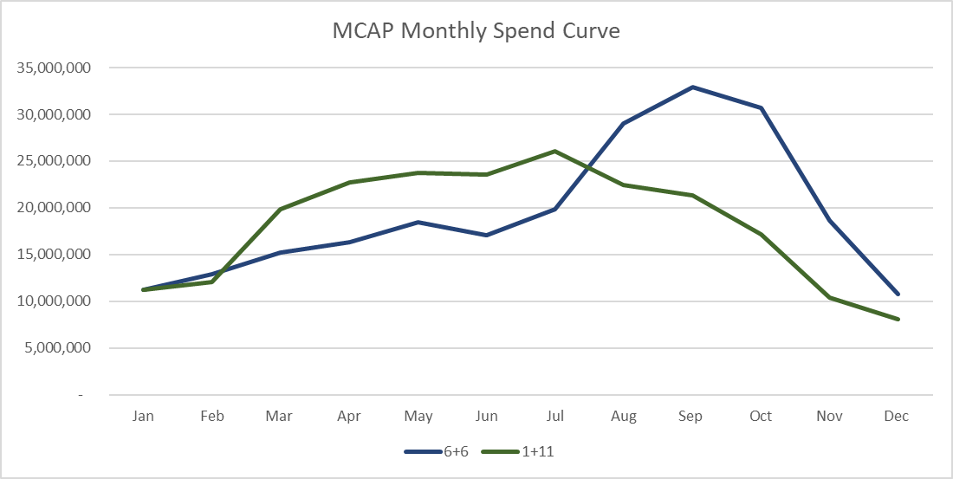

* 1. The task is to reduce the size of the wave. Early detection, habitual optimists, and the like need to be identified, but the data provided to date is summarized to the $218m level and the data is not drillable.

1. Potential Solution: Outline your proposed solution or approach to solving the identified business problem.
   1. Design a program that will compile the massive amount of data and identify the programs and project managers who are contributing the most to the wave.
   2. Each month, there is an additional set of data…
   3. Quarterly re-baselining…
   4. MCAP and MEXP…
2. Demo: Utilize your weekly homework assignments as a guide to demonstrate the practical implementation of your solution. Include actual code snippets and descriptive explanations that can be presented live to the class.
3. Value Proposition: Explain why your project and its potential solution are significant. Highlight the value it brings to the business or industry being addressed.
   1. This data analysis will help determine budget shifts to be made between programs each quarter, replacing fast Q4 spends with well planned, ready to execute programs.
   2. Financial planning.
4. Lessons Learned: Share the key insights and lessons your team gained throughout the project. Reflect on challenges faced and how you overcame them.
5. If We Had More Time: Discuss areas where you would have expanded or further developed your project given additional time and resources.
   1. MEXP
   2. Quarterly re-baselining.
   3. User interface for each project manager to run their own data. (Power BI?)

Details….

1. Data Sets
   1. 01, 02, 03, 04, 05, 06.csv
2. Important Columns
   1. ITEMS – Project Name/Title. Unique identifier (long text)
   2. PROJECT TYPE – One of two values. MCAP or MEXP. “DATA SLICER”
      1. Focus on MCAP first.
   3. PROJECT MANAGER – Name of Employee. “DATA SLICER”
   4. PROGRAM = Name of Program “DATA SLICER”
   5. CY TOT EAC = Current Year total Estimate at Completion. IE how much is forecasted to be spent in 2023.
   6. CY 01Jan ACT = Jan23 Actual Spends
      1. Same for 02Feb, 03Mar, …, 06Jun
      2. You will only find 06Jun Act in 06 Data Set and later.
   7. CY 01Jan FCST = Jan23 Forecasted Spend
      1. Same for 02Feb, 03Mar…, 02Dec
      2. You will only find 01Jan Fcst in 01 Data set.
   8. PCA = Project Controls Analyst, Name of Employee. “DATA SLICER” potencial.
   9. PMO REGION = Geographic Region
      1. SOUTH 🡪 TX to FL and up to TN
      2. EAST 🡪 Maine thru Carolinas, NY and half PA, Caribbean
      3. WEST 🡪 WI, Iowa, Missouri and east through half PA.
      4. CORP 🡪 IT
      5. CORP Pipe&Terminal 🡪 Drawdowns
   10. PMO-Asset Team – Best data for state location right now if needed.
   11. OPPM Project Item ID – Unique Identifier. (numerical & short)
3. BASELINE DATA CRUNCH – Visualize the Wave
   1. What is 1Q23 Baseline
      1. CY 01Jan FCST, 02, 03, 04, …, 12 from 01DataSet.
   2. What is 2Q23 Baseline
      1. CY 01Jan ACT, 02, 03 + 04Apr FCST, 05, …, 12 from 03DataSet
   3. What is 3Q23 Baseline
      1. CY 01Jan ACT, 02, …, 06 + 07Jul FCST, 08, …, 12 from 06DataSet
   4. Plot – should look something like…

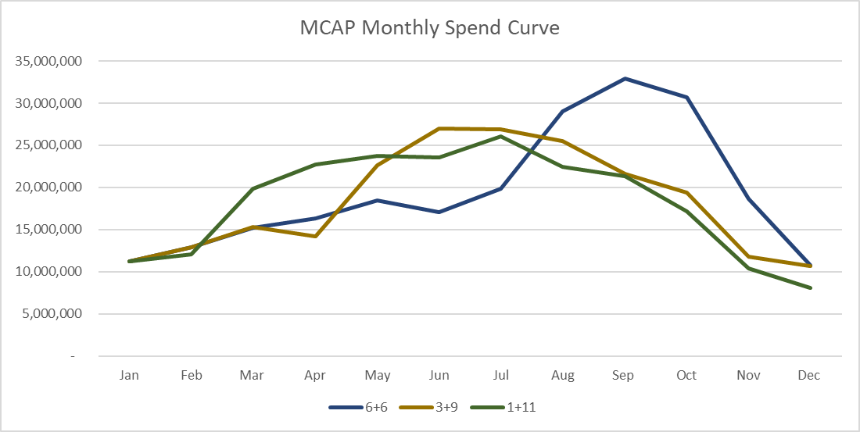

1. NUMBERS DATA CRUNCH

